____________________________________________________________ ____________________________________________________________

Carter Craft Boat Newsletter Jan/Feb 2016
____________________________________________________________ ____________________________________________________________

Season “Rush”!

Ok, it’s -2 degrees out this morning. I went to our local drug store for some items (the car actually started), and when I walked in there presenting themselves out in front…..summer items for the garden. Yes, those metal, stick in the ground, garden thingy’s!

Now, in about 10 days is the first Boat Show of the season. As member of the Niagara Frontier Classic Boat Society we are all set for our display and “manning the booth” times.

Bottom Line---- Spring / Summer are seasons I do not mind the commercialization people rushing! Even though I am brushing snow off the boat cover , I am thinking of what needs to be done to get ready for the season. Sure we have some stormy weather ahead, but we are inching forever closer to that first sighting of Mr. & Mrs. Robin!

Speaking of “Bottom Line” the ad below explains the Royalite bottom utilized for only a few years due to the fasteners popping out. I have this bottom on mine and it seems to be doing just fine. Only issue is explaining to on lookers that it was a factory option and not something someone applied over the hull. I will post a picture of the ad at the next show. I always try and have a nice story board out in front when I display the boat, you can’t be there the whole time and it’s important to get the “History Told”!

Ed Dominiak
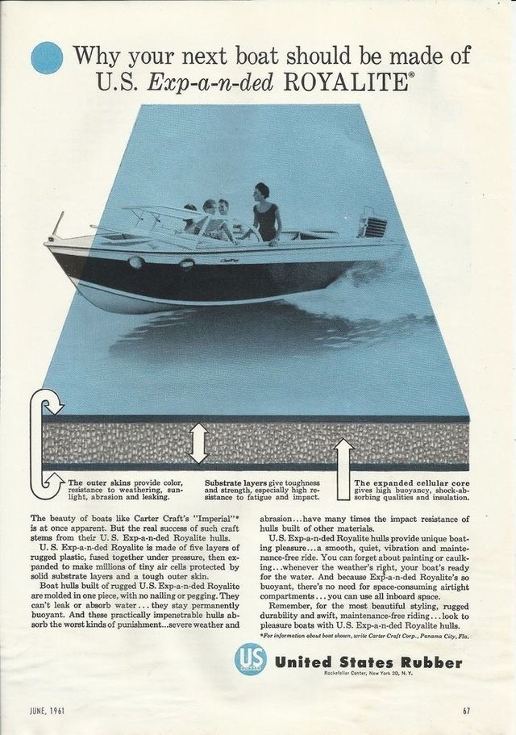

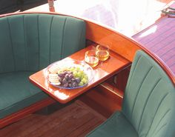 Here’s a neat idea I found while searching images on Google. A slide out table. Now this just might be the next addition under the center bow. I think a couple cup holder holes will be added.

For sale
1957 Carter Craft Sea Lark Hull only no motor or trailer Major Project ...interior structure excellent but needs total reskin and redeck but all there for patterns including original ...solid and keel is straight and transom is great This was the premier ski tow boat for Busch Gardens in the 50s Have Gator Trailer and choices of power available ...
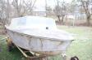
Seen on Craigslist – Elizabeth town TN.

This little quote was referred to in Classic Boating Magazine a few issues ago. It brought to mind a picture I found of a Cater Craft Boat owner:

………..So this guy knows what he has , a production boat that is unique in character, not readily found for sale on any classic boat sites and a “head turner” when seen.

Please enjoy the “hobby” of owning and showing a classic boat. Get those younger people in your life acquainted with it and maybe even interested in helping maintain it. I feel a Boat ride is nice, but if you get them to actually help clean, varnish or paint it can start the “love affair” of classic boating.

Also, please send picture of your boat! We need to post these whenever we can to keep the alive and well….on GOOGLE!!!

